

**Project: Network Infrastructure Configuration**

|  |  |
| --- | --- |
| Name | ID |
| Karen kamal wadea | **21028315** |

**List of content**

|  |  |
| --- | --- |
| Introduction | 1 |
| Project Objectives | **2** |
| Device used | **4** |
| configuration | **5** |
| ping | **14** |

**Design :**

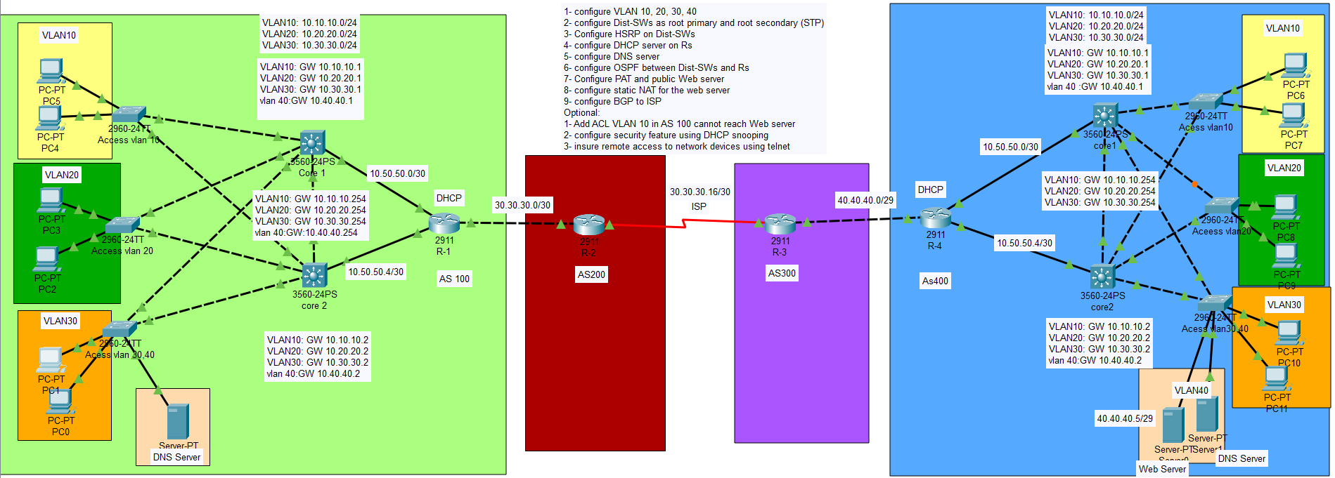

**Introduction:**

In today’s dynamic business environment, network infrastructures need to be robust, scalable, and secure to support critical operations and services. This project focuses on designing and implementing a comprehensive enterprise network with an emphasis on high availability, redundancy, and security. Through the use of advanced technologies like VLANs, HSRP, STP, OSPF, BGP, DHCP, DNS, and NAT configurations, the project aims to provide efficient traffic segmentation, seamless failover, and optimal routing performance, ensuring the organization’s network can handle both internal and external demands with minimal downtime.

**Project Objectives:**

**1. VLAN Configuration:**

**Configure VLAN 10, 20, 30, and 40 to segment network traffic.**

**2. Spanning Tree Protocol (STP):**

**Configure Dist-SW1 as the primary root bridge and Dist-SW2 as the secondary root bridge for VLANs using Rapid Spanning Tree Protocol (RSTP).**

**3. Hot Standby Router Protocol (HSRP):**

**Configure HSRP between Dist-SW1 and Dist-SW2 for gateway redundancy to ensure network failover.**

**4. DHCP Server Configuration:**

**Set up a DHCP server on the Router (R) to automatically assign IP addresses to clients in various VLANs.**

**5. DNS Server Configuration:**

**Configure the DNS server for internal name resolution, ensuring that all devices within the network can resolve hostnames effectively.**

**6. Open Shortest Path First (OSPF) Routing:**

**Configure OSPF between Dist-SWs and Routers (R) to ensure dynamic routing within the internal network.**

**7. Port Address Translation (PAT) & Web Server Configuration:**

**Set up PAT to allow internal users to access external networks using a single public IP.**

**Configure a public web server to be accessible externally.**

**8. Static NAT Configuration:**

**Set up Static NAT to map the public IP address of the web server to an internal private IP.**

**9. Border Gateway Protocol (BGP) to ISP:**

**Configure BGP to establish routing between the internal network and the Internet Service Provider (ISP).**

**10. Access Control Lists (ACL):**

**Configure ACL to ensure that traffic from VLAN 10 in Autonomous System (AS) 100 cannot access the public web server.**

**11. DHCP Snooping:**

**Implement DHCP snooping to prevent unauthorized DHCP servers from assigning IP addresses and mitigate possible attacks.**

**12. Remote Access Configuration:**

**Enable telnet access to all network devices for remote management and troubleshooting.**

**Devices Used:**

**-12 PCs**

**-6 switches**

**-4Multilayer**

**-4Routers**

**-3Servers(2DNS and 1 web server)**

**CONFIGRATION OF SWITCH(Access1):** 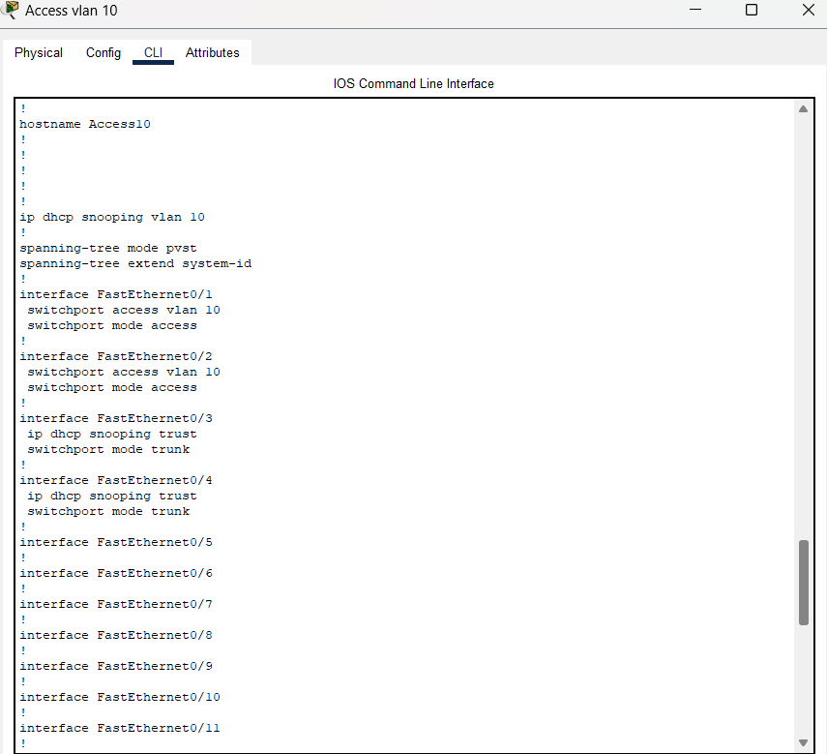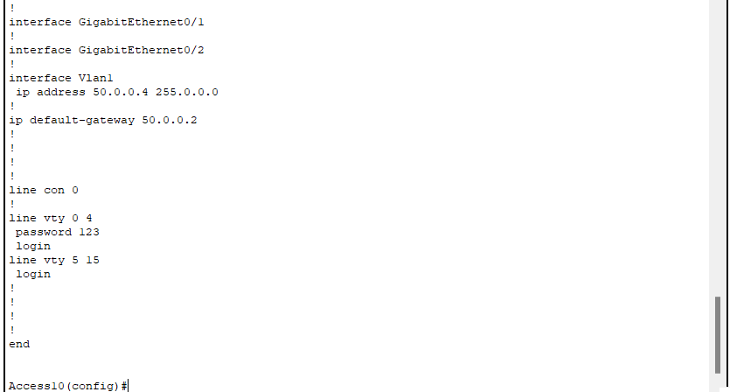

**CONFIGRATION OF SWITCH(Access2):** 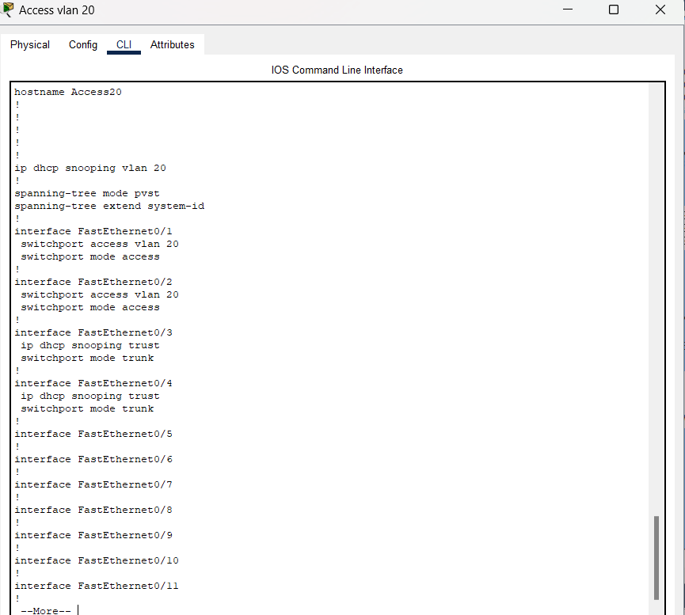

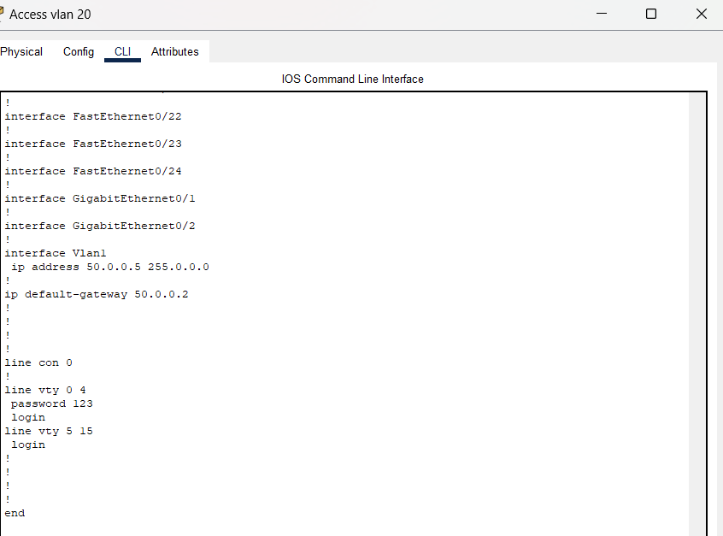

**CONFIGRATION OF SWITCH(Access3):**

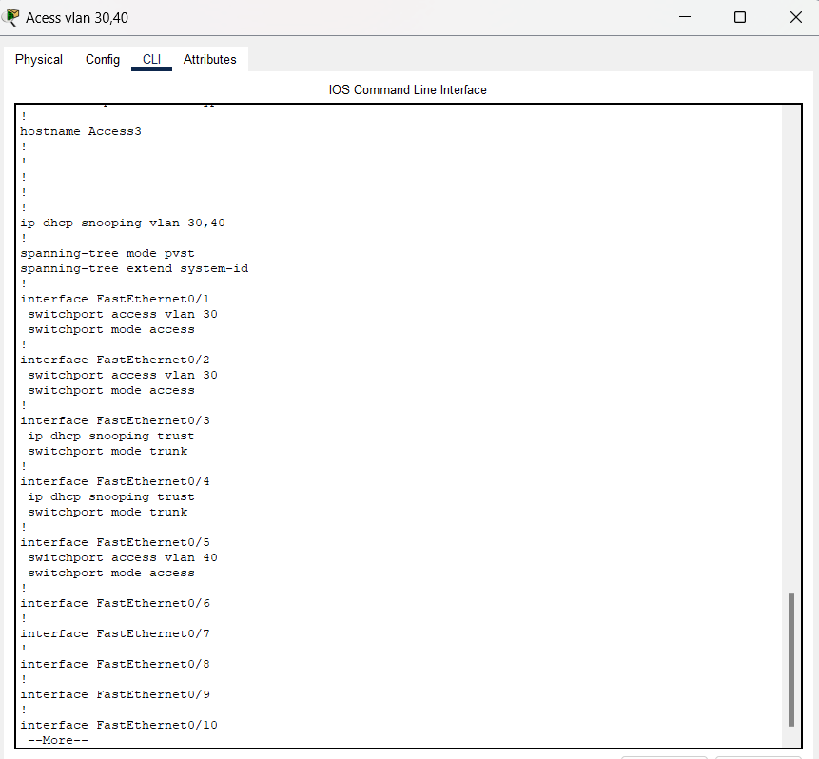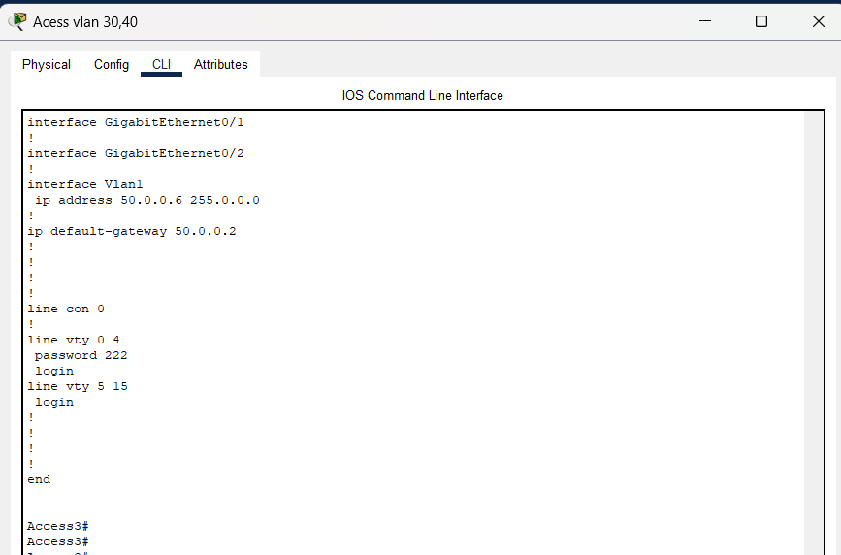

**Configrution of (Core1):** 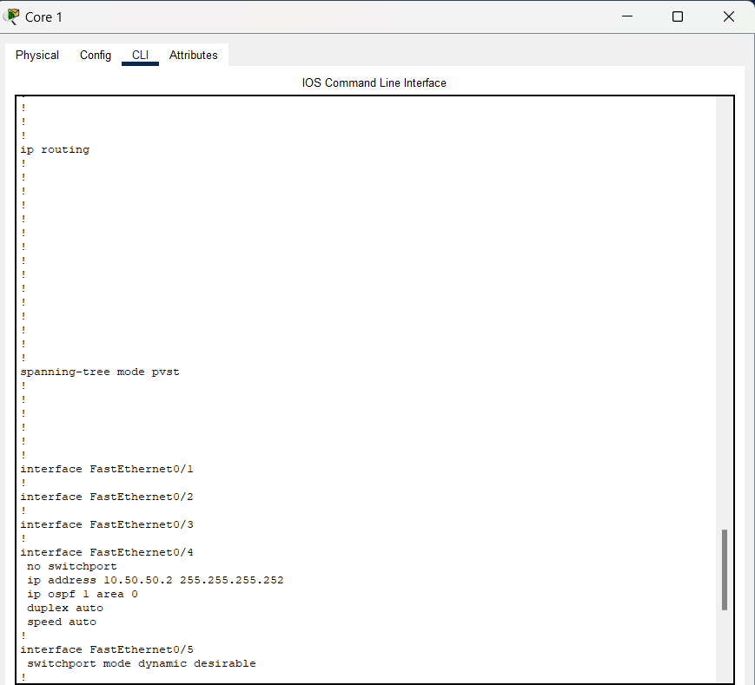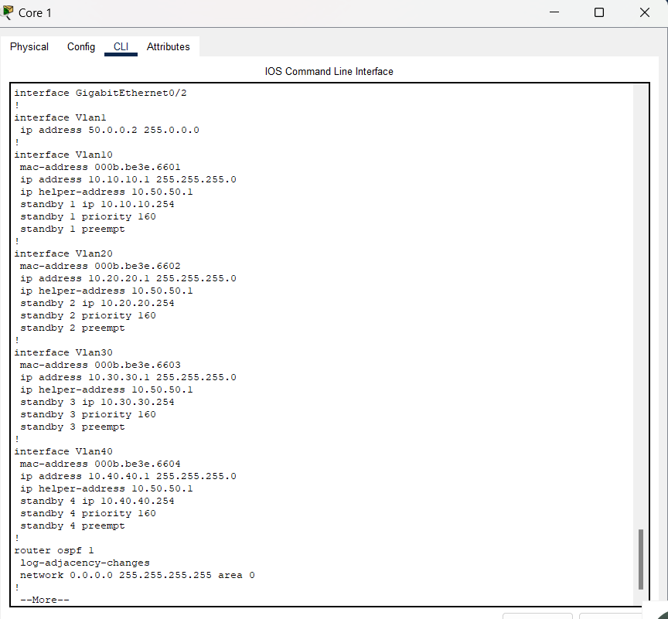

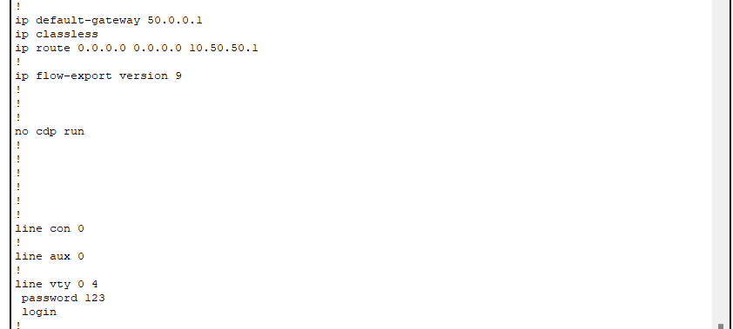

**Configrution of (Core2):** 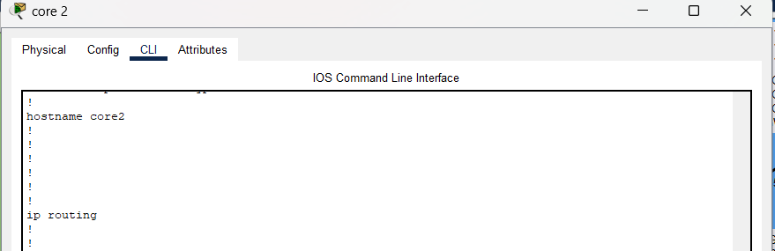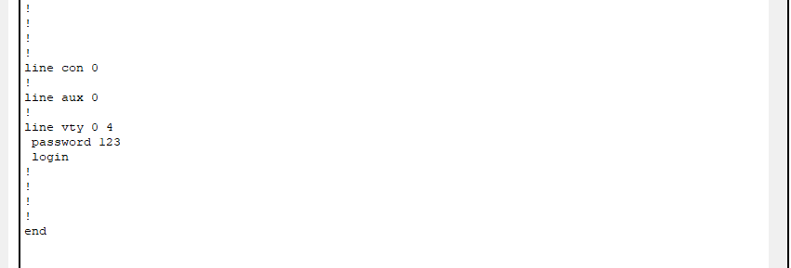

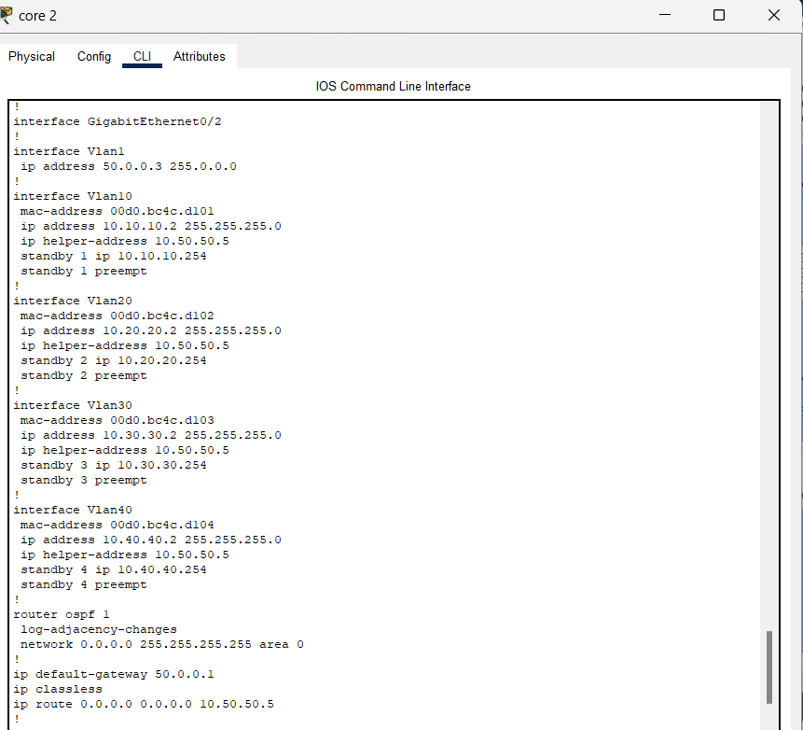

**Configrution of)R-1):**

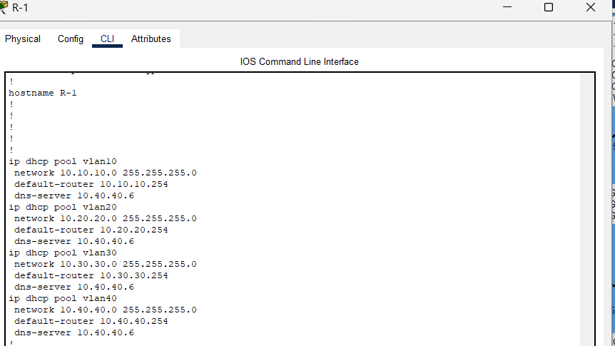

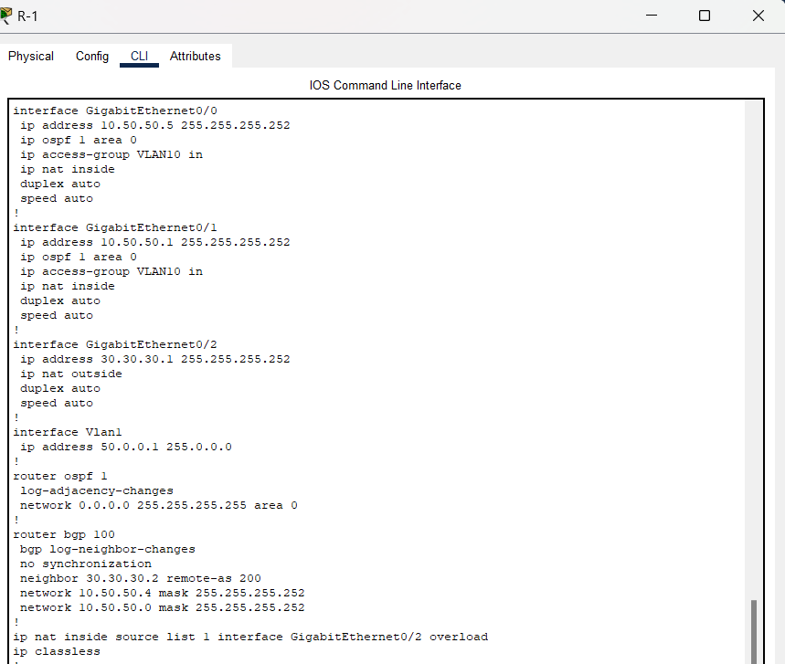

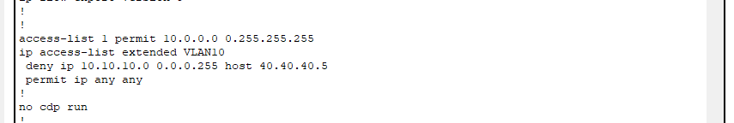

**Configrution of)R-2):**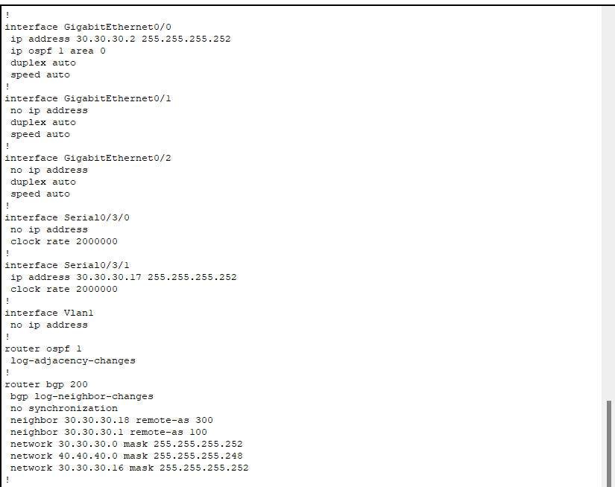

**Configrution of)R-3):** 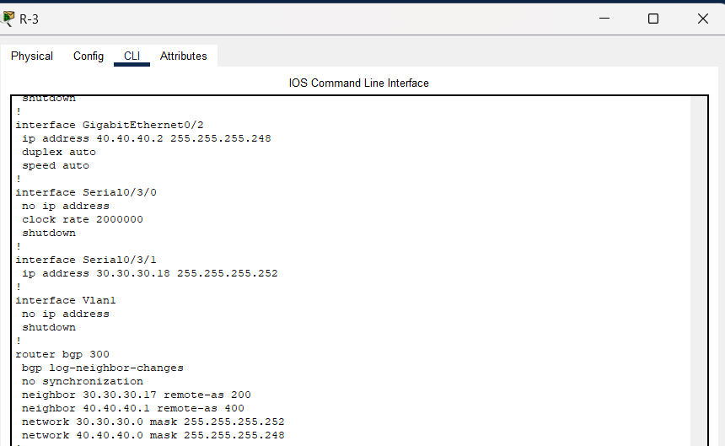

**Configrution of)R-4):** 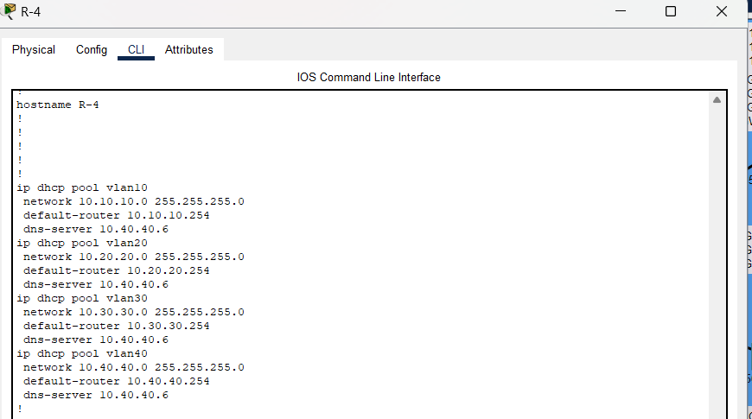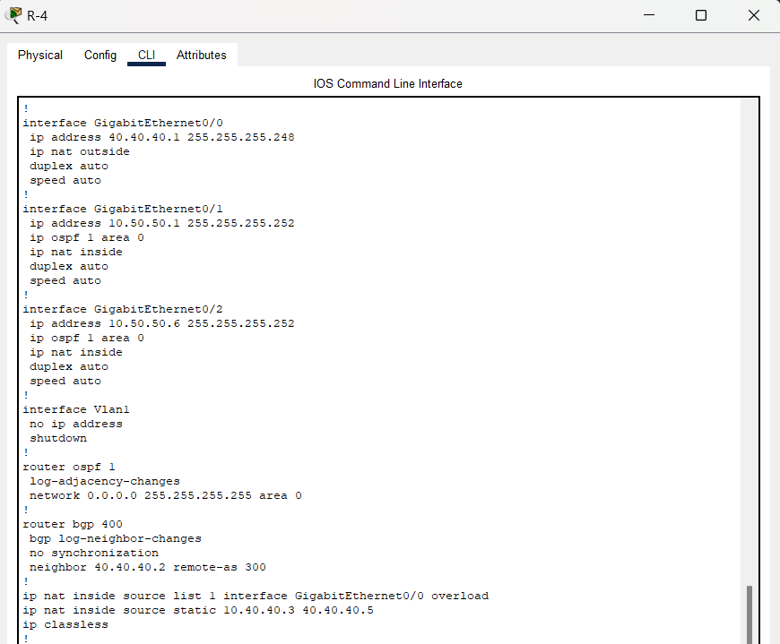

Ping from vlan 10 to vlan 10 in AS 400

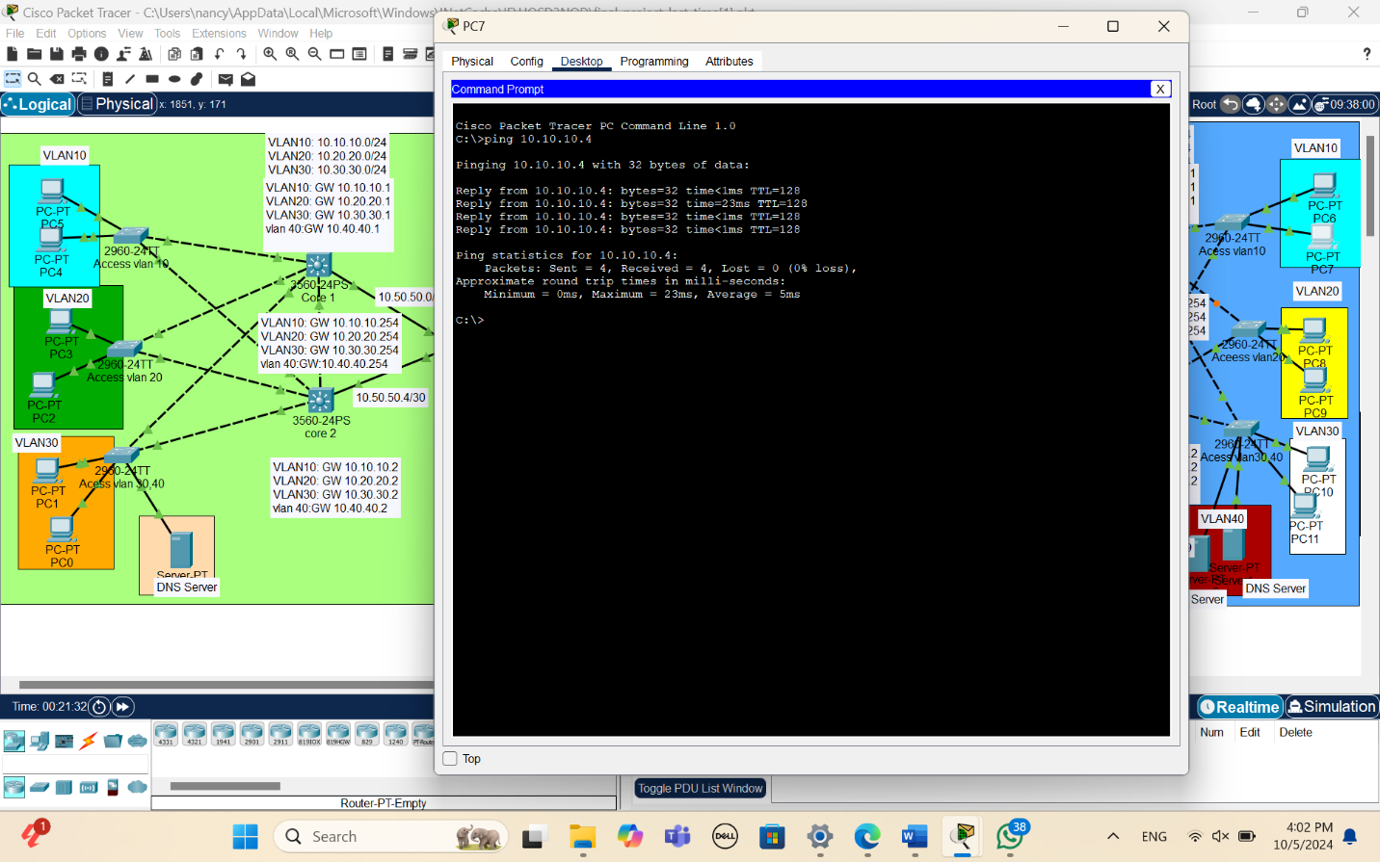

Ping from vlan 20 to vlan 20 in AS 400

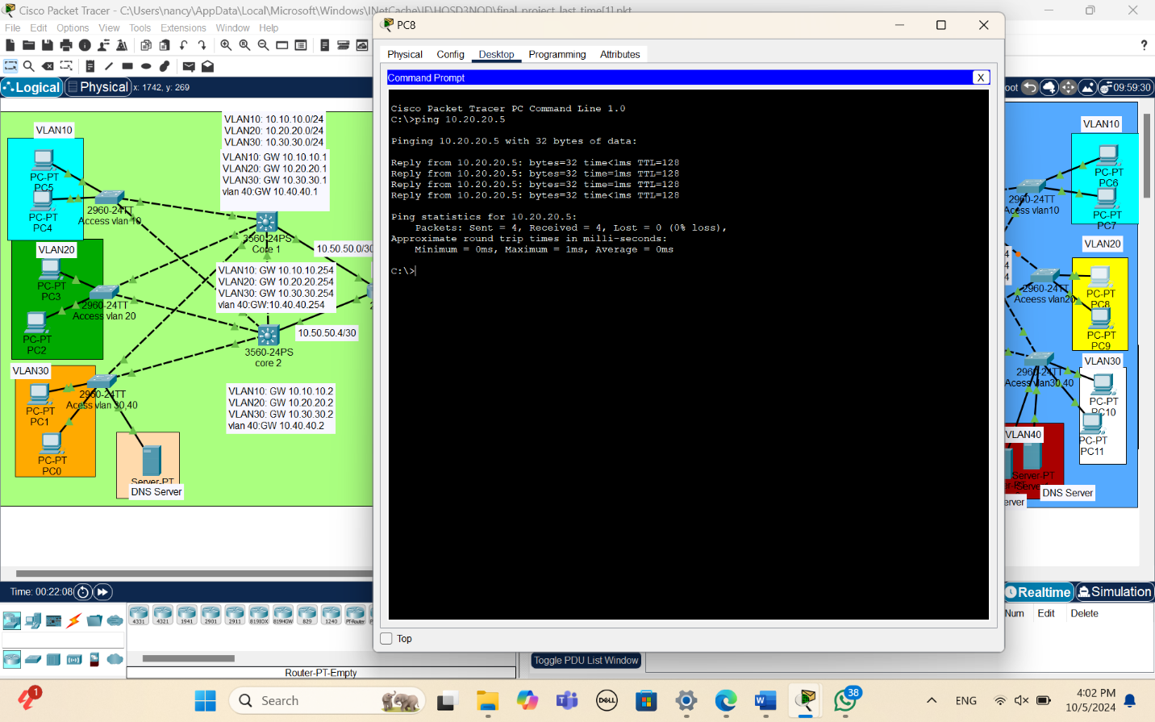

Ping from vlan 30 to vlan 30 in AS 400

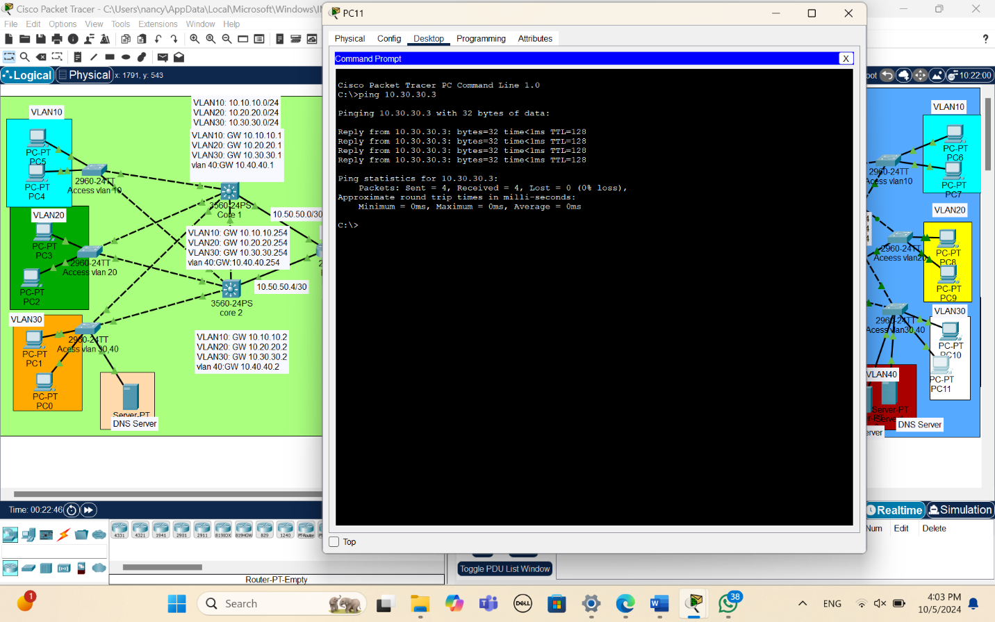

DNS Server in AS 400

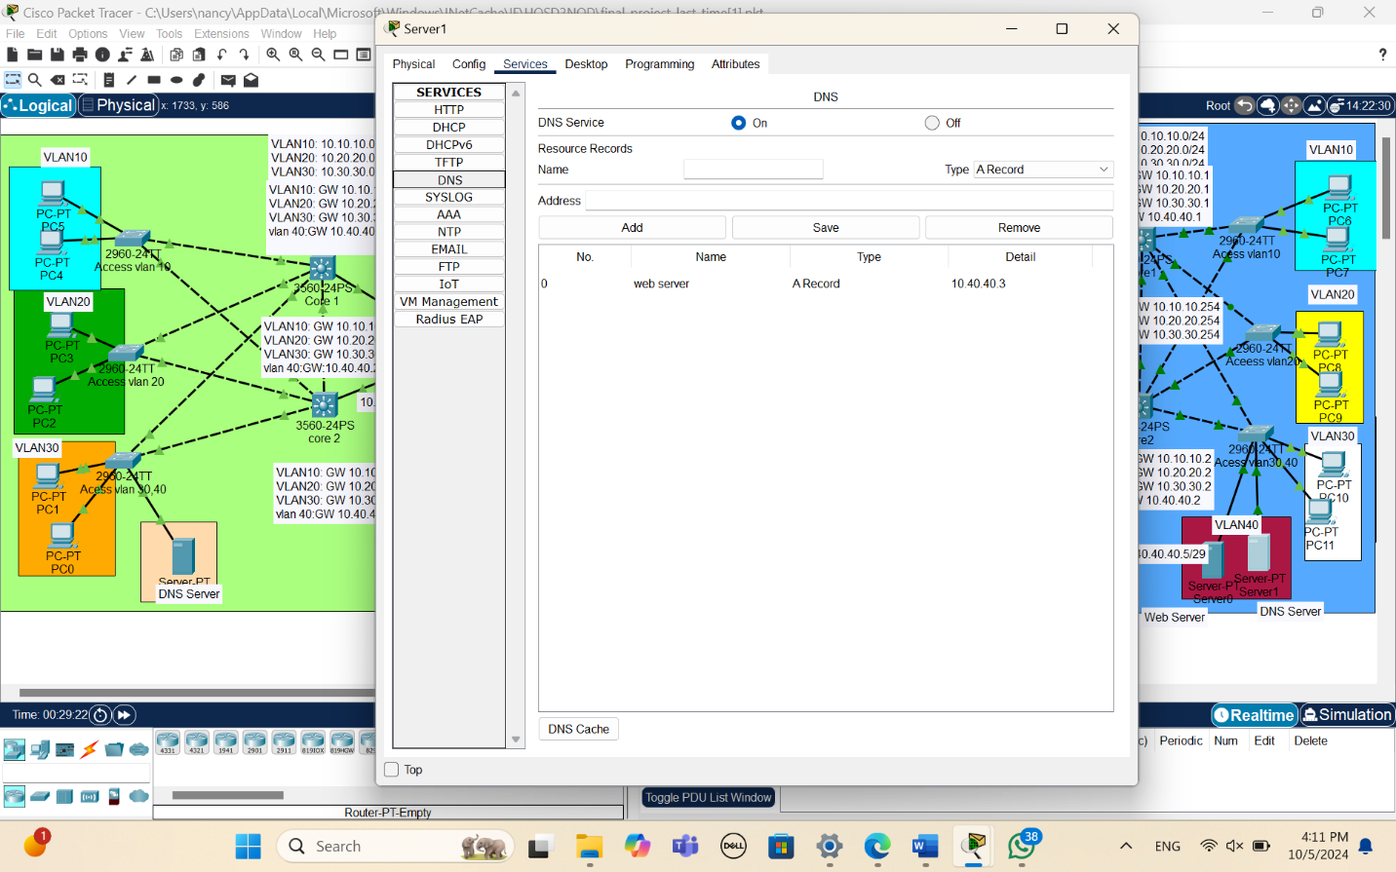

ping on web server in as400 from vlan 20

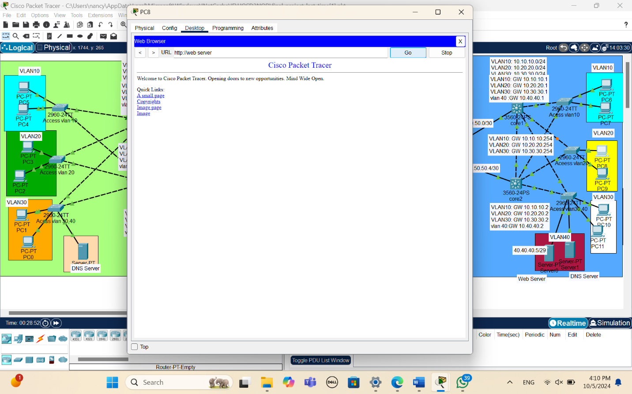

PC7 in vlan 10 took ip address from DHCP in as400

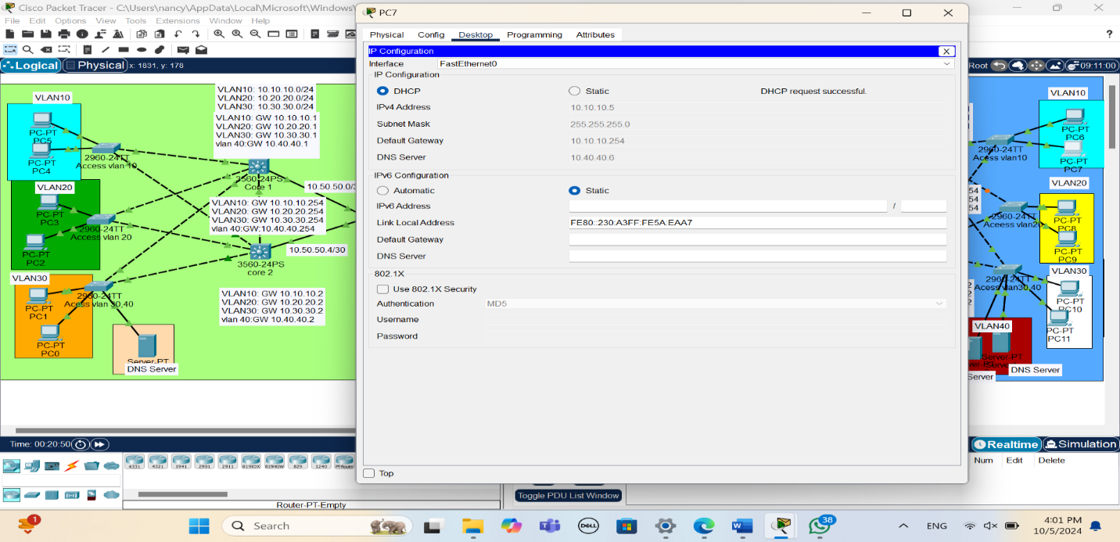

Ping from vlan 10 to vlan 20&30 in AS400

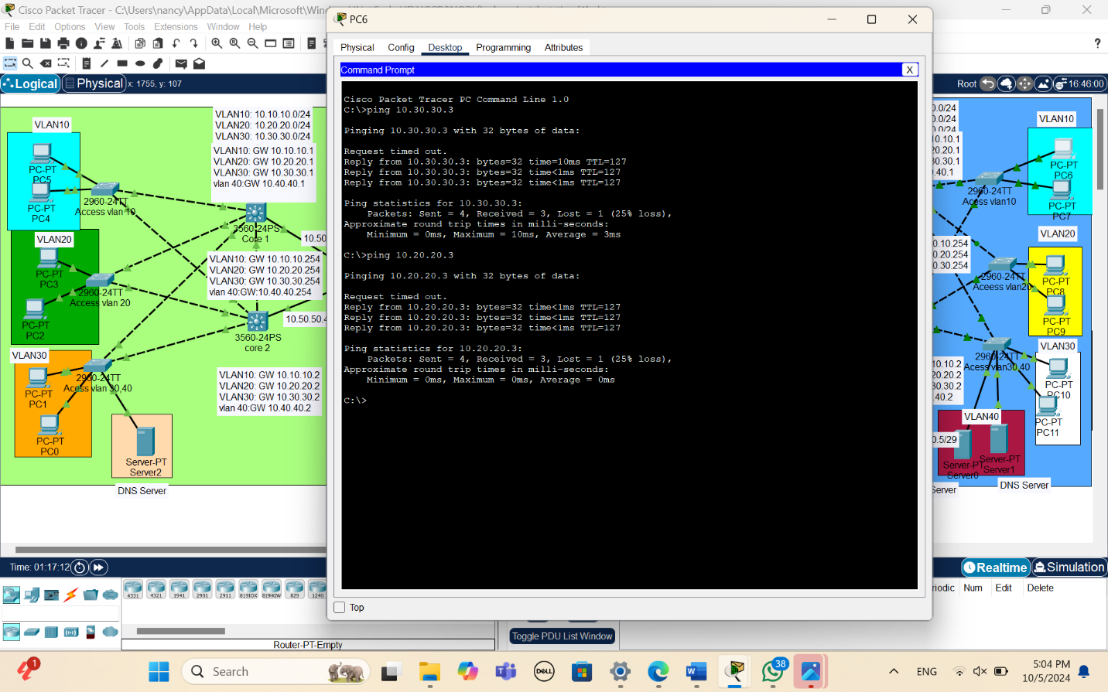

For PAT (ping from vlan 10 to ip of router 1) in AS400

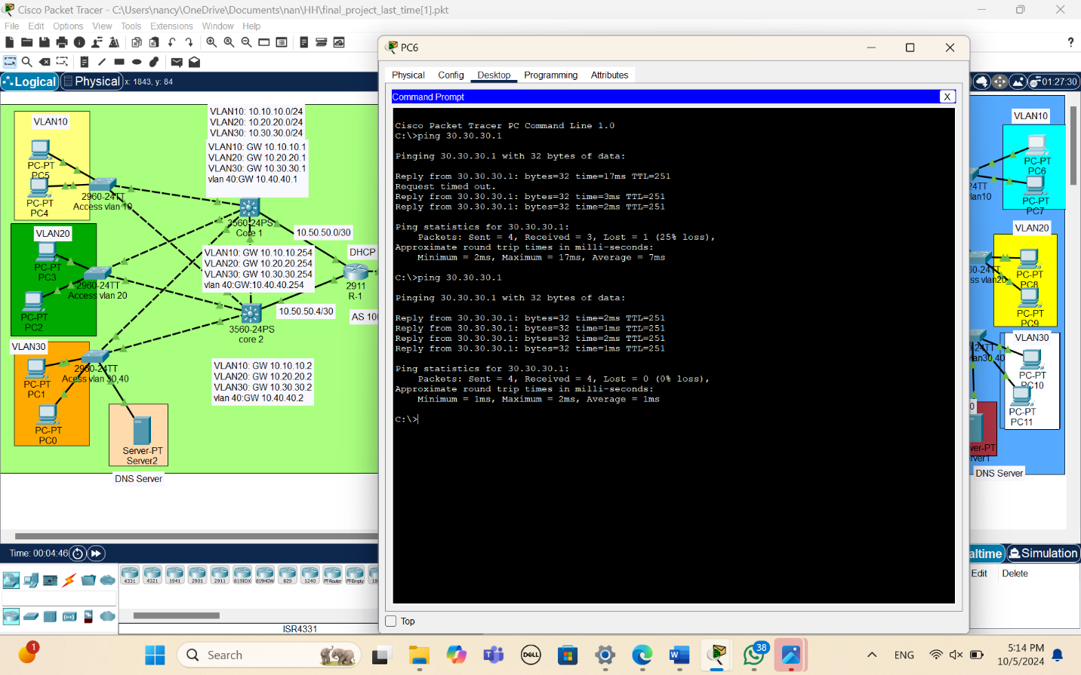

AS100:

Pc5 in vlan 10 cannot access web server due to access list control

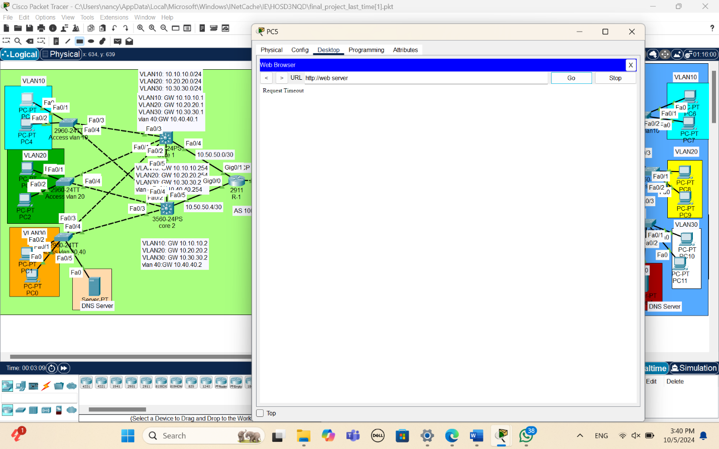

Pc1 in vlan 30 access web server by it is public ip

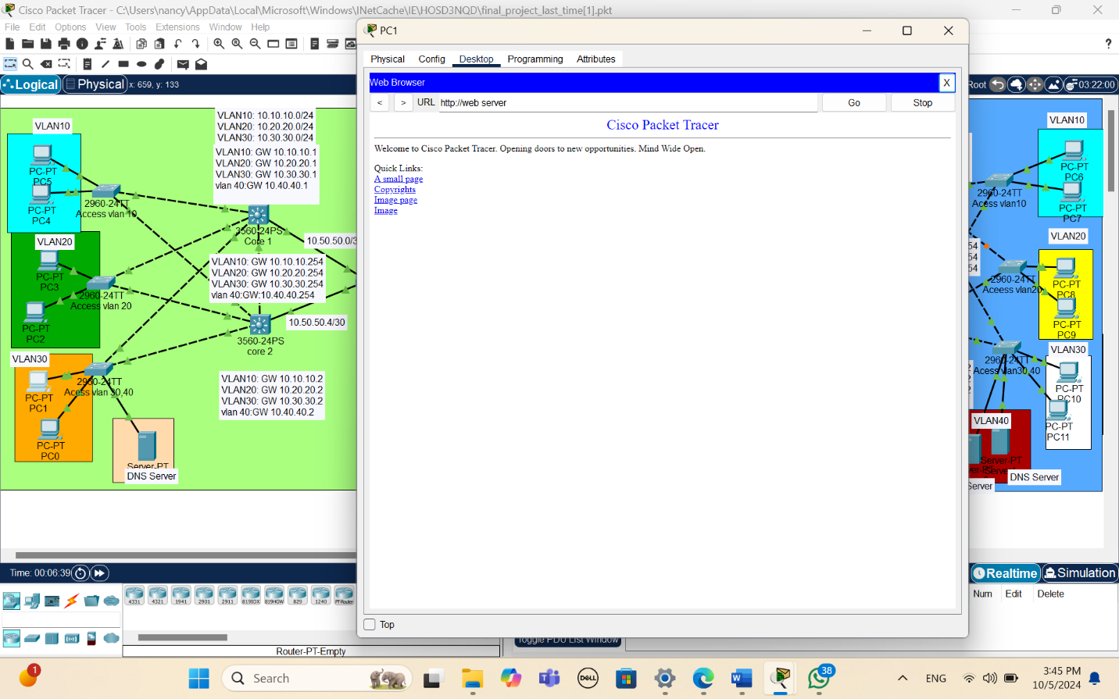

DNS SERVER

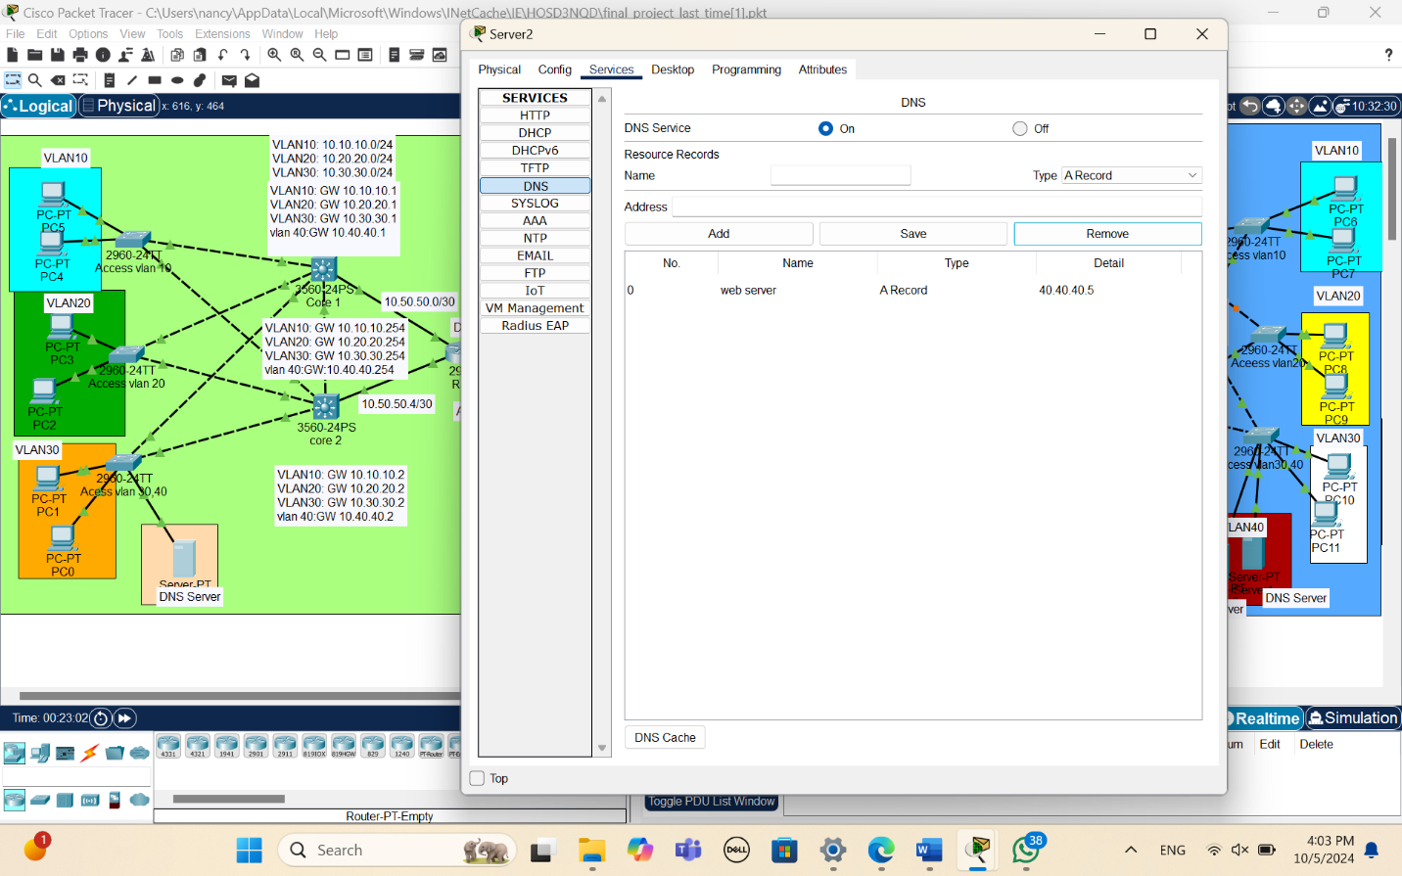

Ping from vlan 20 to vlan 20

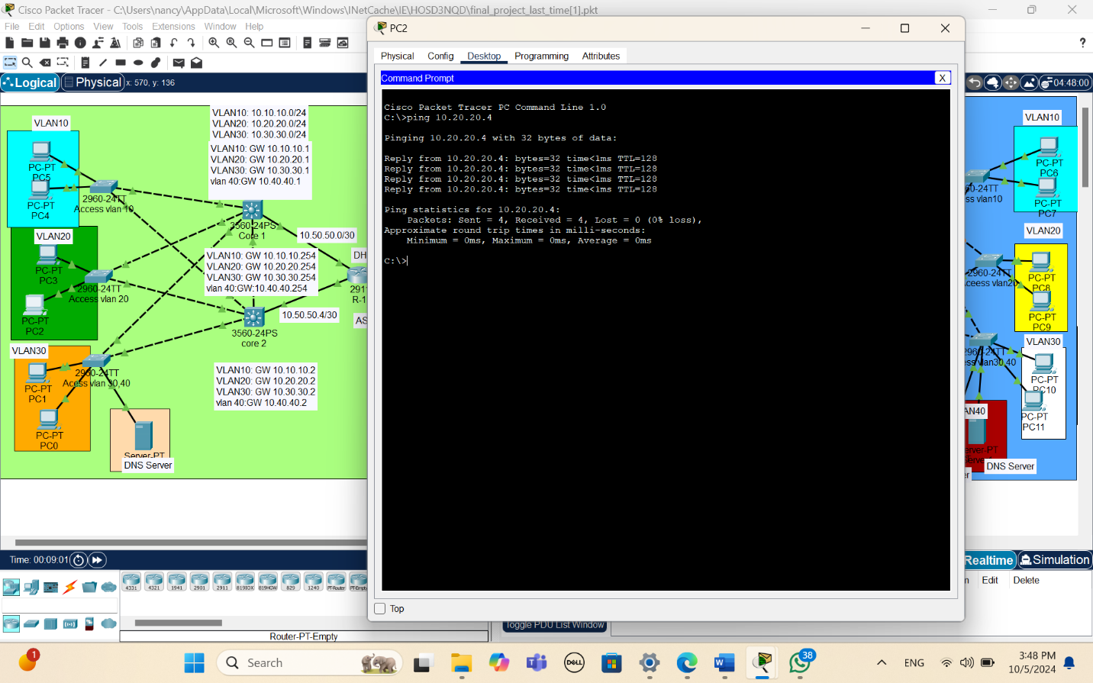Ping from vlan 30 to vlan 30

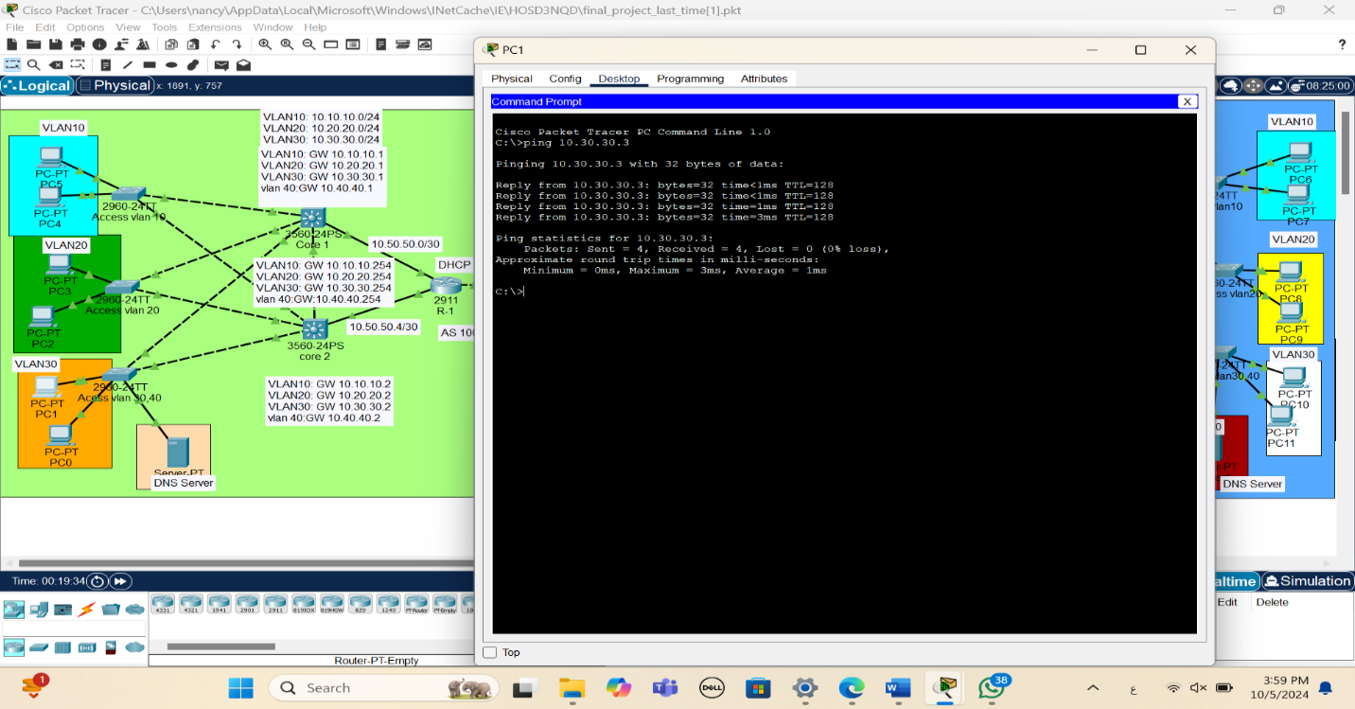

Ping from vlan 10 to vlan 10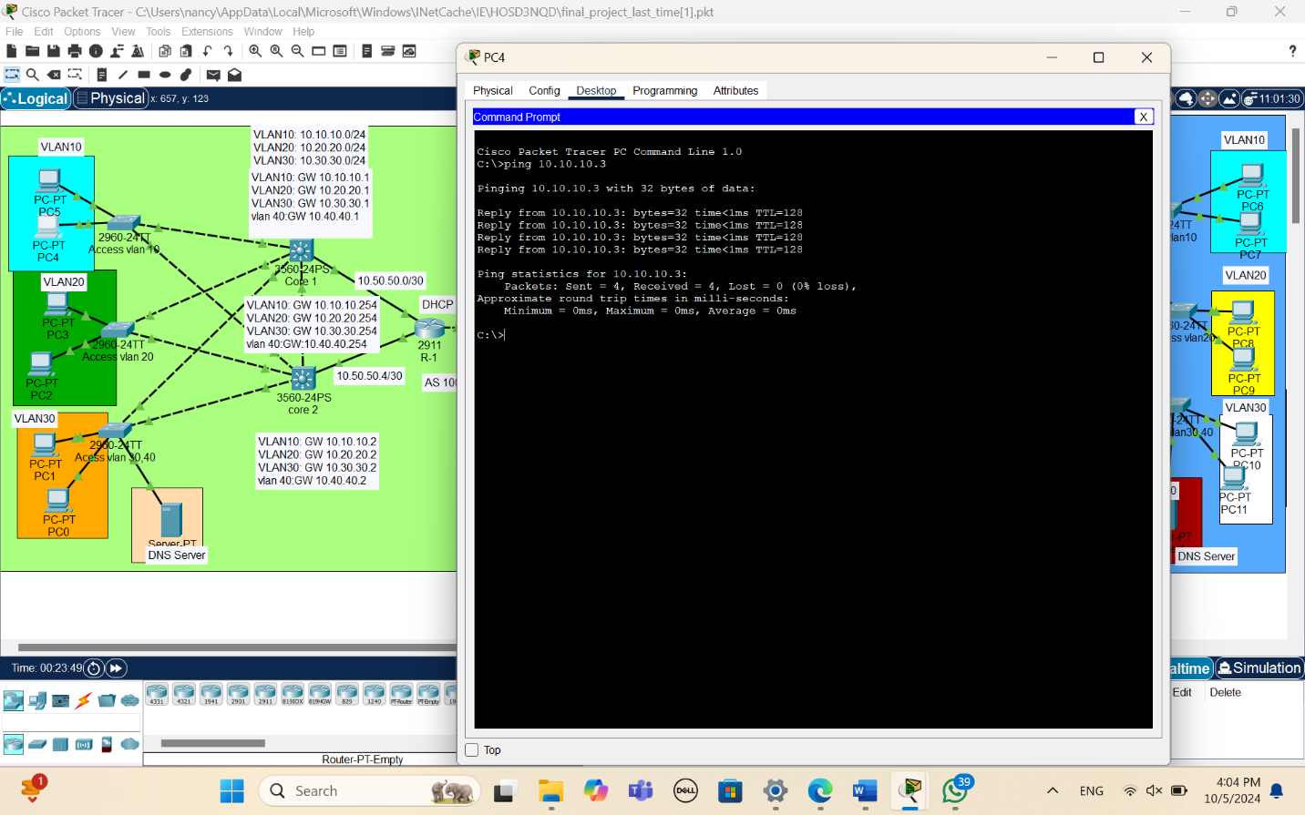

Ping from vlan 10 to vlan 20&30

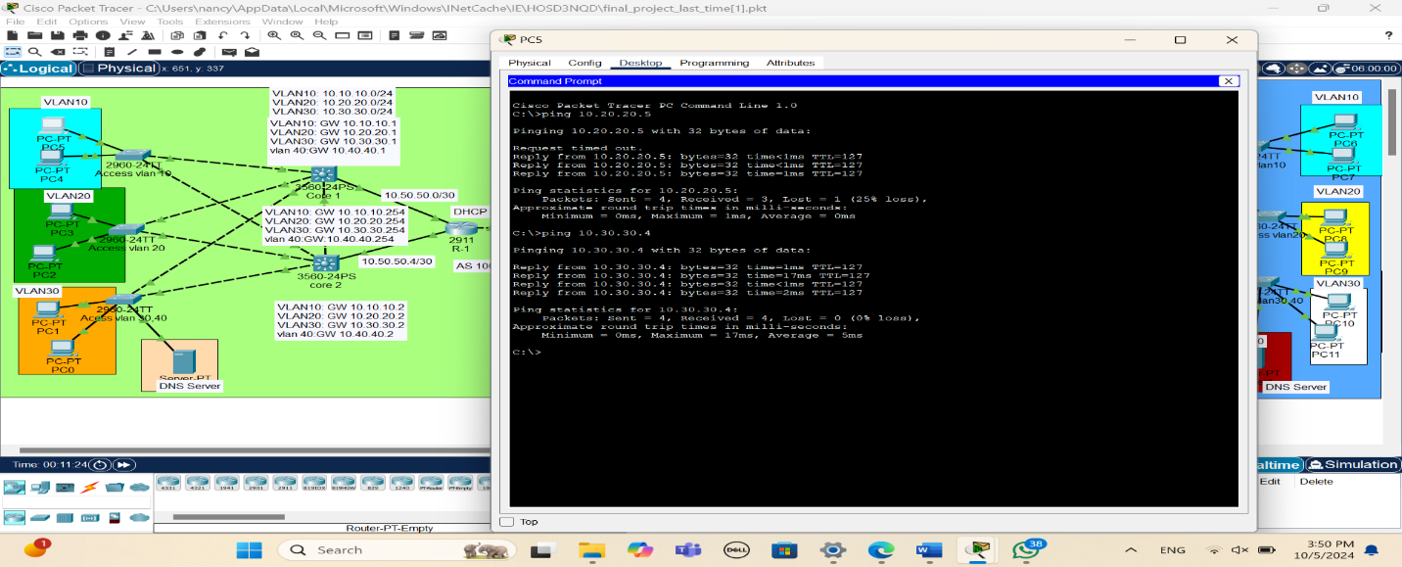

0PC4 in vlan 10 & PC2 in vlan 20 took ip address from DHCP

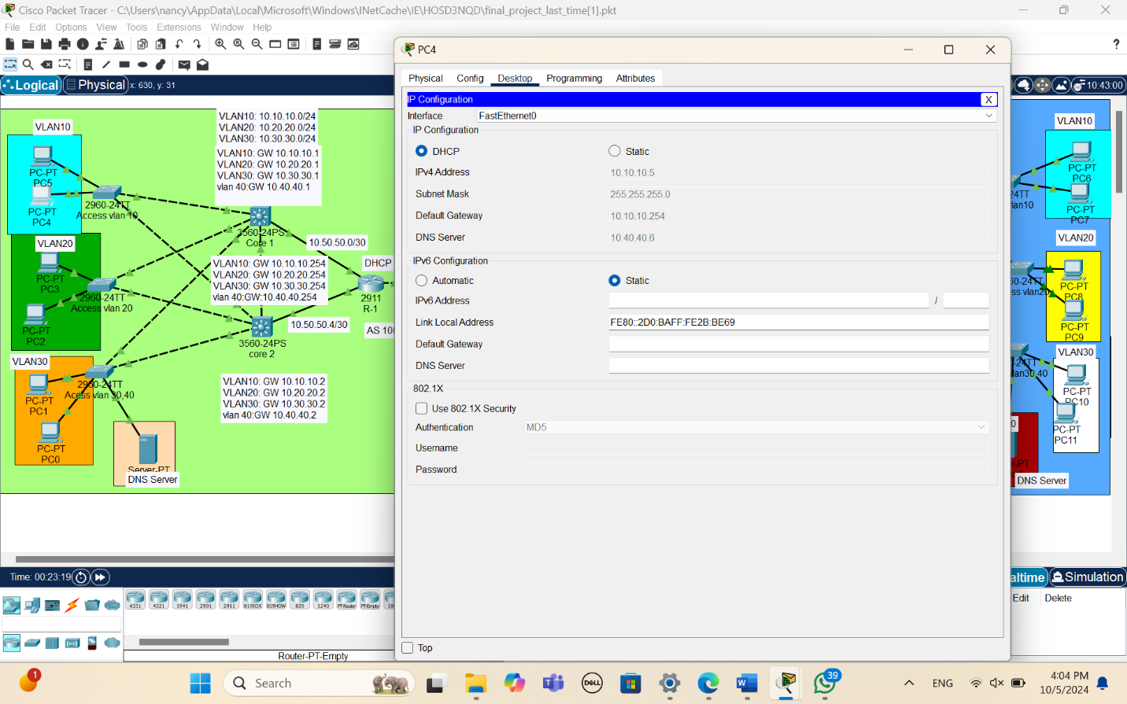

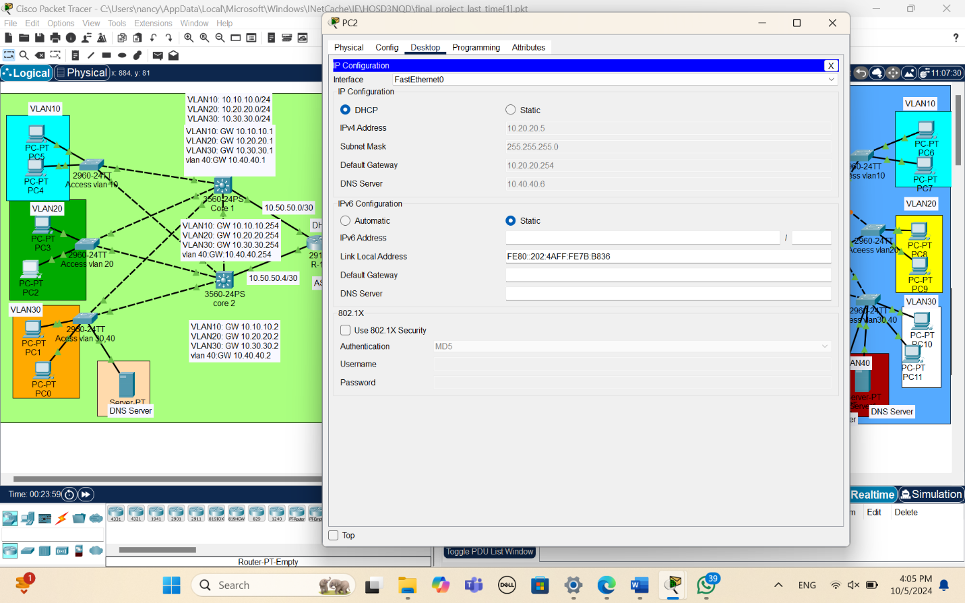

telnet from pc4 in vlan 10 to Access vlan 30,40 swtich

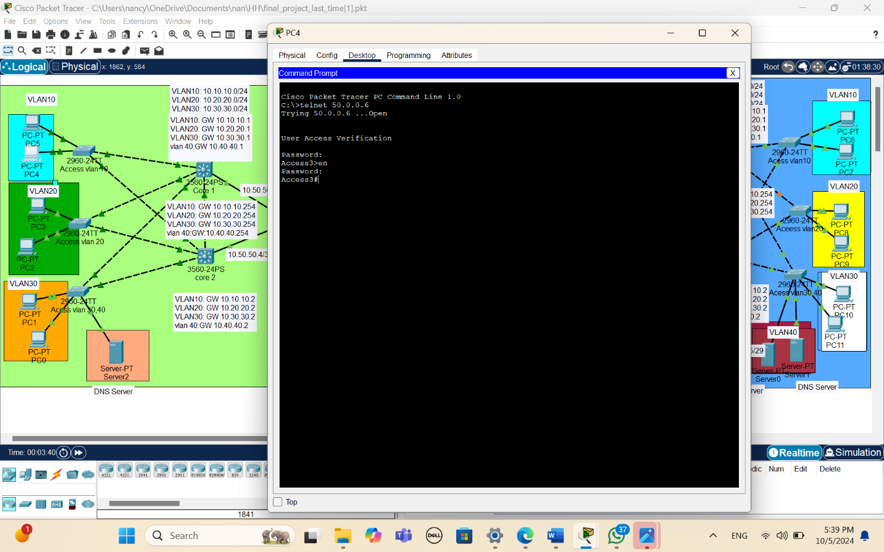For PAT(ping from vlan 30 to ip of router 4)

